**16 Old Brock Road, Puslinch, ON N0B 2J0**

**519-763-7040 @AberfoylePS**

June has arrived! Enjoy reading about what is happening at your school. We will also be sending home a Summer Newsletter close to the end of June that will give you an overview of events in June, along with a list of important September dates to note.

I am also very pleased to announce that I will be returning to Aberfoyle next school year.

All the best,

Paul Tribe, Principal

**PD Days 2017**

Please note for babysitting purposes that there is no school for students on the following days:

* June 9,
* June 30th

**JUNE ACTIVITIES**

|  |  |
| --- | --- |
| **DATE** | **EVENTS** |
| **01** | EQAO Gr. 3 and 6 (Last Day!) |
| **02** | PM – Sharks Swimming – Gr. 3 |
| **05** | Earth Science Museum trip – Gr. 4 |
| **06** | Junior Track and Field |
| **07** | Intermediate City Track and Field |
| **08** | Intermediate City Track (Rain Date)\  African Lion Safari - Kindergarten |
| **09** | PD Day (no school for students) |
| **12** | Junior Track and Field (Rain Date) |
| **13** | Book Fair |
| **14** | Jan Sherman – Gr. 5, Gr. 5/6 |
| **15** | Junior City Track and Field |
| **16** | Junior City Track and Field (Rain Date)  Crazy Hair Day  PM – Sharks Swimming – Gr. 3 |
| **19** | Dairy Presentations |
| **20** | 6:30 AM - Gr. 8 Depart for Quebec  Medieval Times – Gr. 4  Dairy Presentations |
| **21** | 8:45 AM - Colour Day Play Day (Red and White Theme), Zumba Fest! |
| **22** | 9:00 AM - Kindergarten Orientation – Library |
| **23** | PM – Sharks Swimming – Gr. 3  7:30 PM – Gr. 8 return from Quebec |
| **27** | Report Cards Home |
| **28** | Last Pizza Day  Gr. 8 Graduation |
| **29** | 9:00 AM – Final Assembly |
| **30** | PA Day (no school for students) |
| **JULY 1C:\Users\ptribe\AppData\Local\Microsoft\Windows\Temporary Internet Files\Content.IE5\C59X0PHS\Maple_Leaf.svg[1].png** | **HAPPY 150TH BIRTHDAY, CANADA!** |
| **Sept. 5** | First Day of 2017/18 School Year! |

**Track and Field**

On Thursday, May 18, the Grade 7 and 8 students enjoyed the school track and field competition both here and at the Puslinch Centre. Our team of athletes are now prepared to represent Aberfoyle Public School at the City Track and Field Meet at the University of Guelph on June 7.

**Aberfoyle Yearbook on Sale!**

We are very excited to offer our 2016-2017 school yearbook! The yearbook is in full colour and includes all of the year’s best memories. Our yearbook provider is Lifetouch.

* The yearbook will be available to order online from May 24th to June 9th. You can purchase them at: <https://ybpay.lifetouch.com>.
* Prices are in **Canadian funds**. Softcover books are $25.00. Unfortunately, hardcover copies are already sold out.
* Your child’s yearbook will be delivered to your son or daughter during the last week of school.
* **Our school access code is: 13146017**

Don’t delay! You don’t want to miss out on this wonderful keepsake.

**Aberfoyle Fall Fair Preparation!**

For the past several years, children from our school have participated in the Aberfoyle Fall Fair in a variety of ways.  Every year about this time we start to gear up to complete activities for students to enter.

On the entry tag that each child completes there will be space for a first name but never a last, except for the teacher's name.  This entry is submitted in the Fall.   The address is always listed as the school’s.  If you would **not** **like your child** to part of this school-wide initiative please write this in your child's agenda.

The Fair happens the first Saturday after school starts at the Puslinch Community Centre. This year, the date would be Saturday, September 9, 2017. At 9:30 there will be games for the whole family to participate in.  Please stay tuned for more information!

Mrs. Hauwert needs 300 flyers (Zehrs, etc.) to cut up and also 30 egg cartons to get ready for the Fair!

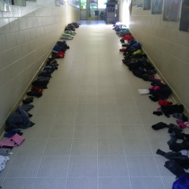**Lost and Found!**

We have quite a collection along the ramp and in the hallway. Please check it out as it will soon be gathered together and taken to a charity. Thanks!

**Colour Day Talent Show a Hit!**

On Wednesday May 17th, Aberfoyle held its first Colour Day Talent Show. Fifteen Aberfoyle students exemplified the 'E' in A.C.E. ("excel everyday"), as they shared their unique skills with the entire school. From musicians to dancers, comedians to magicians, we saw it all. We would like to thank participants for showing bravery as they presented their talents to their teachers and peers. An additional thank you goes out to the Grade 6 Community Builders, who took the time to teach us about what made each performer special, through their creative introductions during the show. We can't wait until next year to see what other unique and amazing talents are here at Aberfoyle! Thanks again to all our performers.

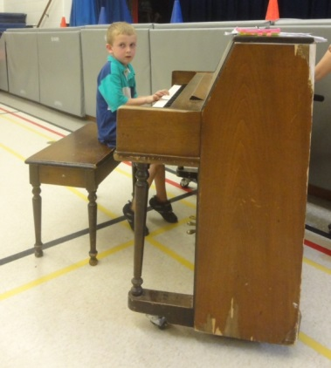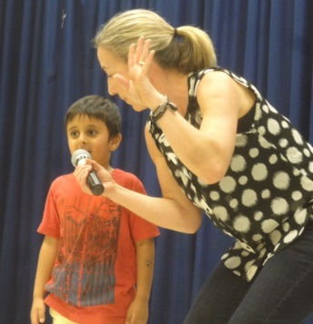

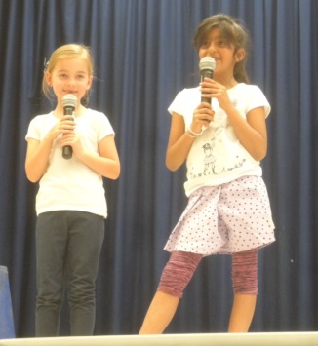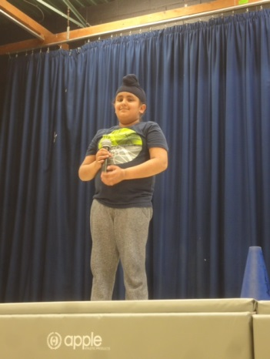

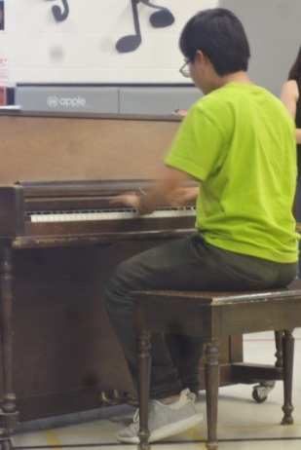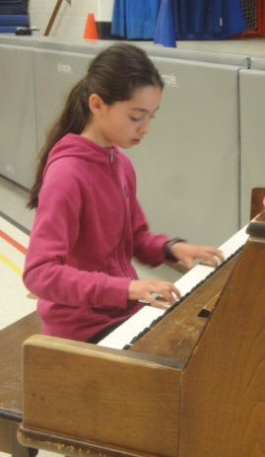

**An Alternative to Fundraising**

Sometimes, rather than getting involved with fundraisers, people choose to support their school by giving to the **Upper Grand Learning Foundation**.

Donations of $20 or more to your **School Fund** receive a tax receipt. Donate through the [UGLF website](http://www.uppergrandlearningfoundation.com) at [www.uppergrandlearningfoundation.com](http://www.uppergrandlearningfoundation.com)



Here is the link to our Aberfoyle School Council Facebook group. It will give you access to what is happening with our School Council.

<https://www.facebook.com/groups/1509233629393288/>

As is usual, we had an excellent meeting on May 10. The next one will be on **Thursday, June 15 at 6:30 PM**. We would love to see you. This meeting will be a chance to talk about a barbeque and open house planned for **September 28.** Come out and get to know an excellent group of people making a difference in your school and provide your ideas and insights.

If you would like to see the most recent minutes, just check out the Facebook page or our website <http://www.ugdsb.ca/aberfoyle/>.

**Great Rhythm!**

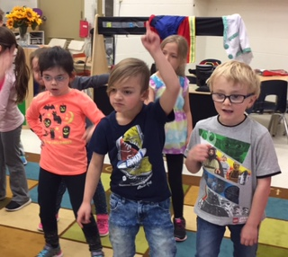

**Explicit Consent – Deadline July 1, 2017!**

****Canada’s Anti-Spam Legislation (CASL) came into force on July 1, 2014. As a result, the Upper Grand District School Board, would like to ensure that we have your consent to receive newsletters, school and Board updates, announcements, event invitations, and other electronic messages.

Some of these messages may contain advertising or promotions regarding school fundraisers, field trips, the sale of yearbooks, student pictures, or similar events.

**If you wish to receive the above communications from us, please visit our CASL registration website at:**

[www.ugdsb.on.ca/CASL](http://www.ugdsb.on.ca/CASL)

If consent is not provided as of July 1, 2017, you will not receive electronic messages and may find it more difficult to be aware of the activities that take place in school, and which your child may have an interest in participating.

If you have any questions or if you wish to withdraw your consent at any time, please click the link at the bottom of email messages you receive from the school, or visit the same site and click on “Unsubscribe” to remove your name from our contact list.

****For additional information on Canada’s Anti-Spam Legislation you may visit our board’s website at [www.ugdsb.on.ca](http://www.ugdsb.on.ca).

**Recess Fun**

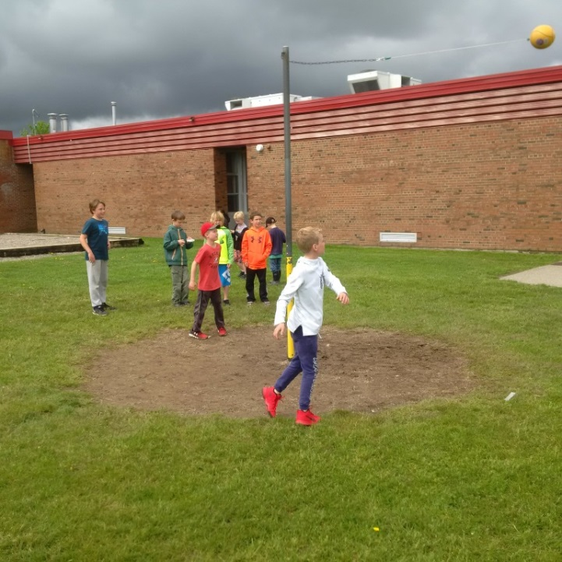

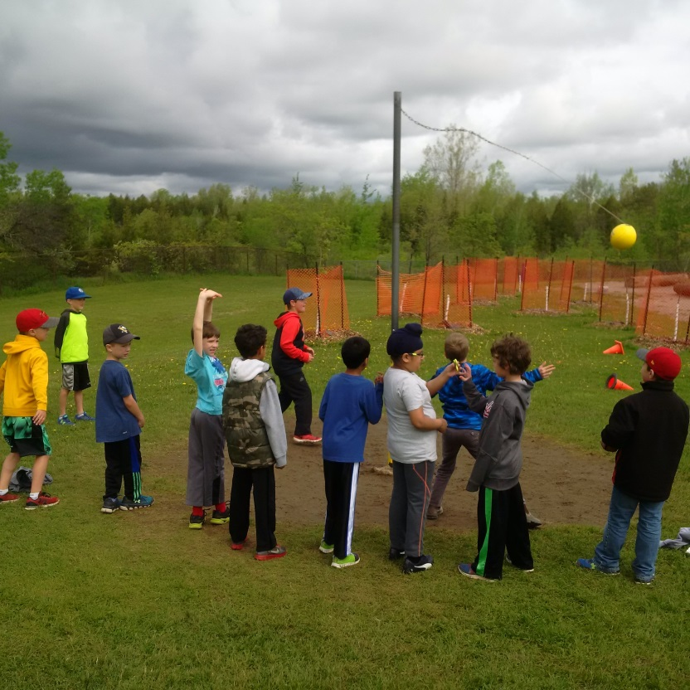

**It is Gardening Season!**

Mrs. Broadhead and her team of gardeners have started to make the front of our school look beautiful. As you can see, the garden is already looking very healthy. Thank you!

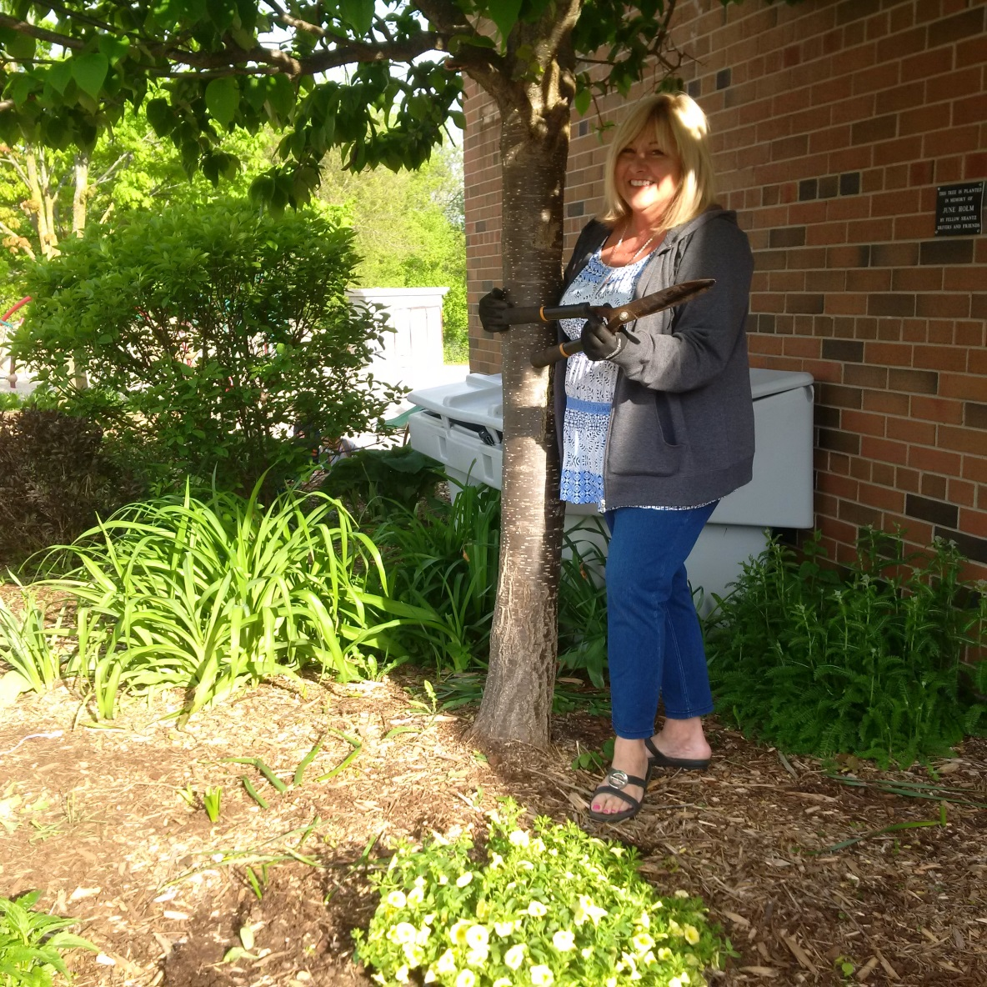

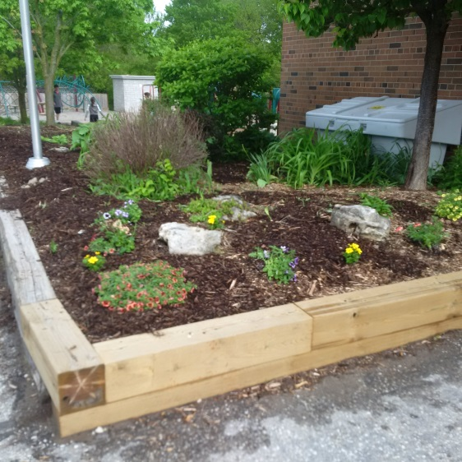

**Ramadan**

The Islamic calendar has 12 months and one of them is the month of Ramadan. The Islamic Calendar is lunar which means it is based on the moon.

During this month Muslims all over the world fast from sunrise to sunset, which means that we can not eat or drink anything from dawn to sunset. We wake up early before dawn and eat and drink a big breakfast, because it will be a long day before we can eat again. Only those people who are healthy are allowed to fast. When the sun sets, we break our fast with dates and water. Then we say our prayers and eat a nice dinner with the whole family.

Muslims pray 5 times a day, but in Ramadan there is a special prayer called the “night prayer”. It is fun to go to the mosque for these special prayers because lots of people come and I see my friends.

At our home we celebrate by sharing food and inviting family and friends over. It is also a month of prayers and the reading of the Holy Quran, as it was during Ramadan that the Quran was revealed.

When we fast in Ramadan, it teaches us patience, respect and to be thankful to God for what we have. It is also a time when Muslims give charity to the people in need. Ramadan is a good time to practice doing good deeds too. But we shouldn’t just wait for Ramadan, we should do them all the time

The end of Ramadan is celebrated with a day of Eid. Eid is a time of joy, exchanging of gifts and being with family, much like Christmas. On Eid day we wish each other by saying EID MUBARAK!

By Fiza, Gr 3 and Ayyan, Gr4 (UGDSB, not Aberfoyle)

**A Handsome Group!**

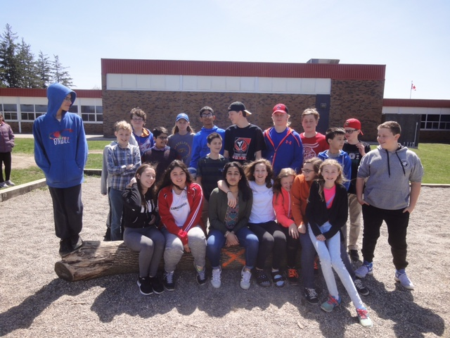

**Medical Concerns**

If your child has a serious medical condition, please contact the child’s teacher and the office. We need to be provided with up-to-date information and medication. A Life Threatening Management Form must be completed by the parent and the doctor. This information will be kept on file and shared so that all staff will be knowledgeable of emergency procedures.

Parents should administer medication at home whenever possible. When medication must be administered by school personnel, it will be kept in the office. Non-prescription oral medication as well as prescription medication requires the completion of an authorization form before medication can be administered. This form is available at the school office.

**Puslinch Library Activities: June 2017**

Below are the programmes offered at the Puslinch library during the month of June.

**Story Time** (All Ages)

Our Story Times are created to help your child get ready for reading.  Share stories, songs, rhymes, and activities aimed at developing your child's early literacy skills. Parents and caregivers are encouraged to participate. Please register.

Thursdays, April 6 to June 15, 11:00 - 11:45 am

**Father's Day Make and Take** (Grades K- 6)

Stop by the branch and make a craft to show Dad how much you love him just in time for Father's Day!

Thursday, June 1 - Saturday, June 17, during branch hours

**PA Day Programme: Safe Kids Week** (Grades K- 6)

Whether you’re walking, cycling, skateboarding, or scootering you’ll want to join in our Safe Kids Week stories, songs and games. Think smart before you start!  K - Gr 2.  Please register.

Friday, June 9, 10:30 - 11:30 am

**Get Your Summer Read On!** (All Ages)

Register for the TD Summer Reading Club, the Teen Summer Reading Challenge, or The “Eh” List Summer Reading Challenge for adults. Get ready to read the North all summer long!

Saturday, June 17, during branch hours

**Canada 150 Ice Cream Social** (All Ages)

Get ready to party! Canada’s birthday is right around the corner, and what’s a birthday without ice cream? Join us for an old-fashioned ice cream social, activities and more!

Saturday, June 17, 11:00 am – 1:00 pm

**Monica North-Gibbons, MLIS**

Branch Supervisor

Puslinch Branch – Wellington County Library

29 Brock Road South, Puslinch ON N0B 2J0

519.763.8026

[monican@wellington.ca](mailto:monican@wellington.ca)

<http://www.wellington.ca/Library>

**Safe Arrival Reminder**

If your child is going to be late or absent, please call the school at 519-763-7040, press extension 100, and leave a message. In order to ensure the safety of your children, if your child is marked absent and you have not called, we will call you. If there is any change in your child’s end-of-day routine, please write a note in your child’s agenda in the morning and Mrs. Warden will get that information from the classroom teacher.

**Safe Departure**

**Please send authorization in writing** if someone other than the legal guardian is going to pick your child up from school. The authorized adult may also be asked for photo identification.

If it is necessary for a child to leave early, or to leave for a period during the day for an appointment, a note must be sent to the teacher. For the safety of your child, we request that you come into the school to **sign him/her out at the office.** We cannot send students out to waiting cars.

**Please** *also remember to sign your child off the bus using the bus lists located in the foyer if they are not taking the bus home. We appreciate your efforts to keep all students safe.*

**Trees for Aberfoyle**

Recently students had the opportunity to plant trees for our schoolyard. We were able to purchase these as a result of a fundraising initiative (selling maple syrup). A special thank you goes to Mrs. Deter for spearheading this program and also to the students, assisted by staff members, who planted and protected our future shade grove so well.

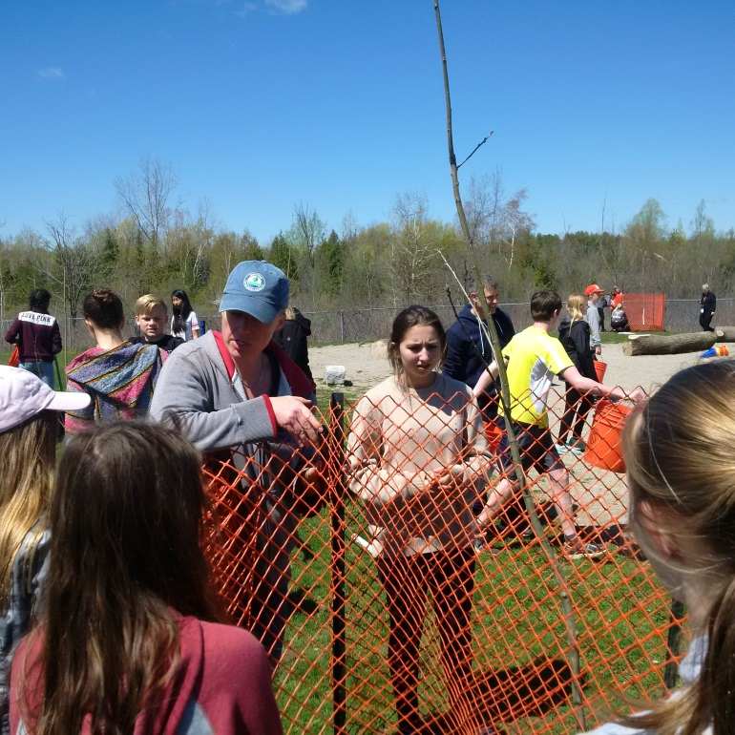

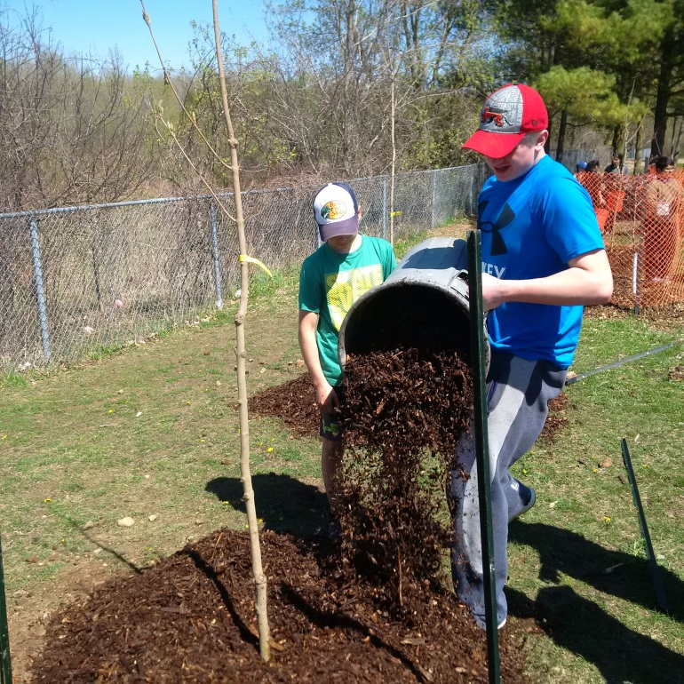

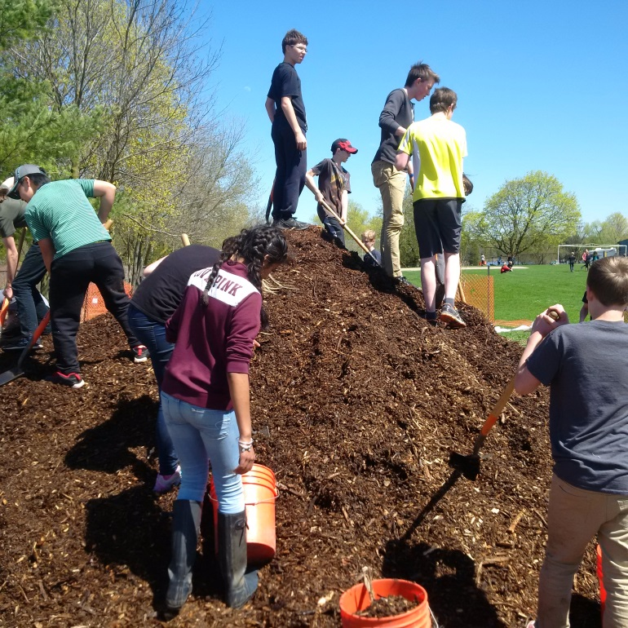

**Life-Threatening Allergies**

We have children in our school with potential life-threatening allergies to various foods and other materials called anaphylaxis. This is a medical condition that causes a severe reaction to food or other materials, and can cause death within minutes. In recent years, anaphylaxis has increased dramatically among students.

Although this may not affect your child’s class directly, we are letting you know so that you may refrain from sending foods to the school that contain peanuts and nuts. We aim to create an allergy safe environment at our school.

If your child is in a classroom with an anaphylactic child, or your child has anaphylaxis, you will be contacted by the classroom teacher.

Our school has procedures in place to help manage anaphylactic reactions. If your child has health concerns of any kind, please tell your child’s teacher or the office and we will take the necessary health protection steps.

***Strong scents*** such as perfumes and certain deodorants can cause an allergic reaction in some of our students and staff who experience sensitivity to these products. Please be considerate of others in the building and try to use scent free products. Our noses thank you!

**Y Activities for PA Days 2016/17**



Check out these links for terrific things to do at the Y and Puslinch Centre. They have attached what the YMCA currently has on their website regarding their sign up brochure for camp and also their link to their website.

<http://www.guelphy.org/wp-content/uploads/2016/09/PD-Day-and-School-Break-Camp-2016-2017-FINAL.pdf>

<http://www.guelphy.org/camp/pd-day-camps/>

****

**Babysitting Course Ages 11+ - 9-4:30 pm 1 Day**

This **Canadian Red Cross course** targets youth aged 11 years of age & up who are planning to start babysitting. Learn basic first aid and how to respond to emergency situations, basic baby and childcare and advice on becoming a responsible babysitter. Develop confidence, create a safe environment and find out tips for getting babysitting jobs.

Upon completion of the course, students are given a Red Cross Babysitter's participatory certificate. Must be 11 years old within 2 months of course date.

**\* are PD Days or Holidays.**

* \* Friday, June 9/17
* Friday, July 7/17

Wellington Centre for Continuing Education

1428 Gordon Street

Fee: $60

**To register online, go to:**

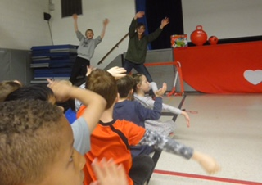[**http://www.ugdsb.on.ca/coned**](http://www.ugdsb.on.ca/coned) **or** [**http://www.learningforyou.ca**](http://www.learningforyou.ca)

**Call: 519-836-7280**

**School Bus Safety**

Now that the weather has changed and we are in the last month of school, it is very important that the driver is allowed to focus on the job of driving children safely to and from school. Most children do sit very well and understand that if the driver is looking in the rear-view mirror to check on noise, he or she is not as focused on the road.

**Child Care at Aberfoyle Public School!**

The YMCA-YWCA of Guelph has committed to the Upper Grand District School Board to operate an extended day program for JK/SK children as well after- school program for children in grades 1-6 at 3 new locations this September. The programs will run from 3-6pm, Monday – Friday on instructional school days. As we start to enroll your children we will determine whether or not before school is needed.  
  
The 3 locations are *Aberfoyle Public School*, Central Public School and William Winegard Public School.  
  
We are very excited about providing quality programs in the schools and look forward to meeting all of the children and families that we will be serving. We will be busy in the coming months to make sure that we meet all licensing requirements as we prepare for the next school year.   
  
We will be starting registration within the next couple weeks, for September. Please note if you filled out the Survey for the UGDSB you are still required to register with the YMCA-YWCA of Guelph.   
  
If you require information on this program and/or would like to add your name to the enrollment waitlist, please contact:  
  
Terri Kendall, School Age Supervisor at 519-767-2816 [/terrikendall@guelphy.org](mailto:/terrikendall@guelphy.org)   
or Kim Daw, Manager, Child Care Services at 519-824-3885 ext. 235 [/kimdaw@guelphy.org](mailto:/kimdaw@guelphy.org)

**Jump Rope for Heart!**

Thank you for taking part in our 35th year celebration of Jump Rope for Heart! Our school’s Jump Rope for Heart total this year is: **$7,764.30!** Prizes have been distributed.

**Special Olympics**

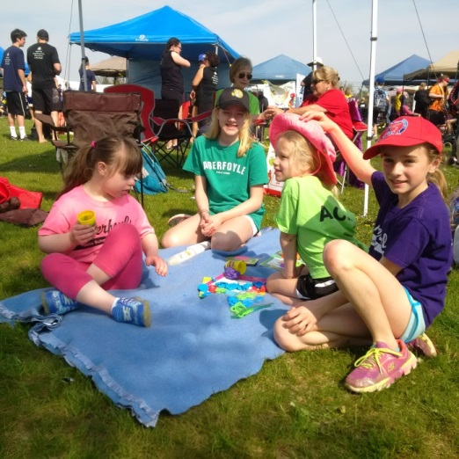On Wednesday, May 17 some students and staff participated in Special Olympics where they enjoyed great weather and enjoyable activities. I know we are all looking forward to taking part again next year!

**ME2WE is Making a Difference!**

As you know, this active group has been raising funds to buy desks for two schools in Kenya. On Wednesday, May 24, they carried out a “Change 4 Change” initiative. Children brought in coins to donate to the cause and received freezies as a thank you.

They raised over $600 that day, which brings the total to over $1600 to date. The goal is to raise $3000 in order to purchase 150 desks.

Well done and thank you, Aberfoyle community for supporting this effort!

**Grade Eight Graduation Information!**

****Grade 8 Graduation will be held the evening of Wednesday, June 28th at the Puslinch Community Centre.

Pictures can be taken outside the Centre from 6:00 to 6:30 p.m. The graduating class will then line up in the side waiting hall.

At 6:45 p.m., the graduation ceremony begins. After the ceremony, the dance will take place in the same hall. Parents are encouraged to dance the first dance with their sons/daughters, and then the students will remain for the dance.

Parents are reminded to return for their graduates at 9:30 p.m.!

**Dress Like Your Favourite Holiday!**

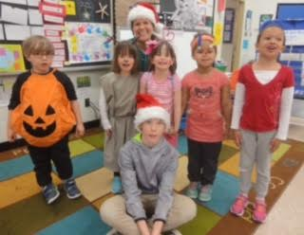

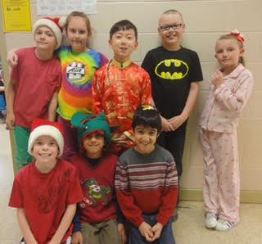

**Transition Plans for Students with Special Needs**

Spring has sprung and it’s a great time to be reviewing your child’s transition plans.  Students who have an Individual Education Plan (IEP) must have a transition plan, whether or not they have been identified as an exceptional student.  A transition plan includes goals for ensuring successful transitions, and the actions for meeting those goals.  It is required if a student may need support making any transition, which may include entering, during, or leaving school.  A plan to support the student must be developed as part of the student’s IEP.

Some transition goals may help with changes throughout the day, such as moving from recess to the classroom, while other goals may assist with larger transitions, such as moving from one school to another or changing grades/teachers within the same school setting.

For many students, the supports provided to the whole class are all they need to have a successful transition, which means they may not need an individualized transition plan on their IEP at this time.

When planning for any transition, the student’s strengths and needs are considered, as well as their physical, emotional, and learning needs.

Please communicate with your child’s teacher if you feel additional transition supports are required on his/her IEP.

**Monthly Environmental Activities**

**to help celebrate our planet**

June 5th is World Environment Day!

*It is vital to teach our children to respect and take care of the environment.*

Celebrate World Environment Day on June 5th!



A Platform for Action- *World Environment Day is the United Nations’ most important day for encouraging worldwide awareness and action for the protection of our environment and is widely celebrated in over 100 countries.*

This year’s theme - *Reconnecting you to nature!*

*On 5 June, go outside and show us that you’re #WithNature. Breathe in the beauty and remember that by keeping our planet healthy, we keep ourselves healthy too.*

This year Canada is the host country! *Every World Environment Day has a different global host country, where the official celebrations take place. This year’s slogan is: “I’m with Nature”.* *Canada is issuing passes giving everyone free entry to all its National Parks for the whole of 2017 as part of its 150th Anniversary celebrations. Be sure to visit a park this year!*

<http://worldenvironmentday.global/en/about/what-is-it>

Ideas for your family to celebrate

World Environment Day!

* Create an event for family, friends and neighbours -There is no end of ideas that you could take forward for World Environment Day. Surprise yourself! Think about ideas that we can do to help the planet like fixing a problem in your community.
* Get out into nature - World Environment Day is all about appreciating the beautiful planet we inhabit. Why not spend a day in a park, hiking a trail or appreciating a forest on the weekend before World Environment Day.
* Inspire others – A great idea will naturally attract others who can take a small idea and make it extraordinary. So, with your powers of persuasion, bring on board the people you think can make your idea awesome. Or ask everyone to make their own personal pledge to change one wasteful or harmful habit for the better. Share what you’re doing using the hashtag: #WorldEnvironmentDay
* Have fun: Make your event for World Environment Day fun, inspiring and interesting. For example, Google events happening locally that you can attend, or check out Pinterest for fun, recycled crafts ideas.

<http://worldenvironmentday.global/en/toolkits#event-kits>

http://worldenvironmentday.global/en

**Grade 7/8 Artwork**

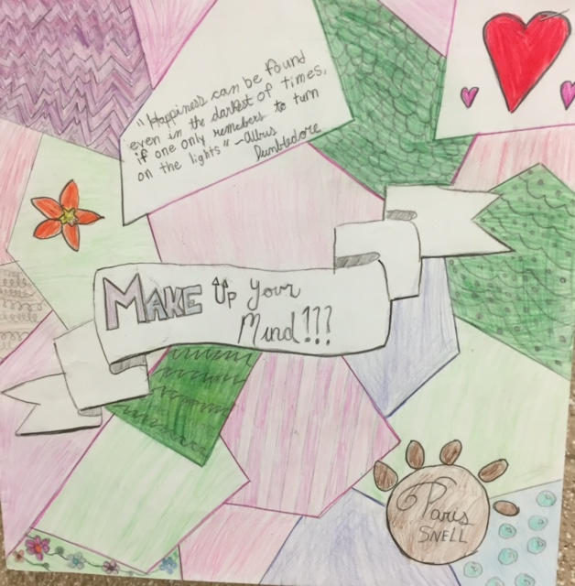

**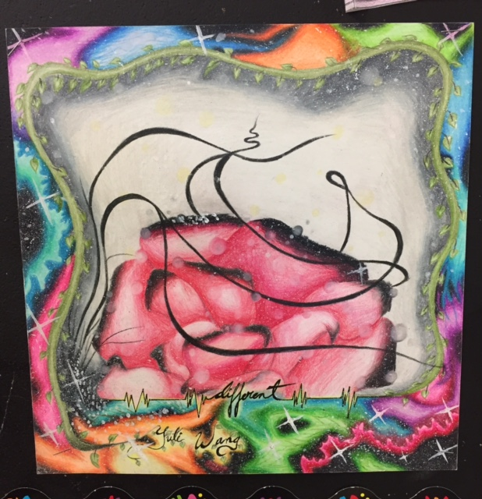**





**EQAO 2017**

During the last period of time our grade 3 and 6 students have been writing this standardized test that addresses language and mathematical skills. Traditionally Aberfoyle students do very well when compared to other students in Ontario.

A special thank you goes out to our staff members who prepared the children so well and to the volunteers who helped ensure all students had an equitable opportunity to display their abilities. It was greatly appreciated!

The acronym stands for the Education Quality and Accountability Office. For more information about this assessment, please feel free to go to [www.eqao.com](http://www.eqao.com).

**Artist Visit May 2017**



**We Love Music!**

